Writing workshop with Learning Development
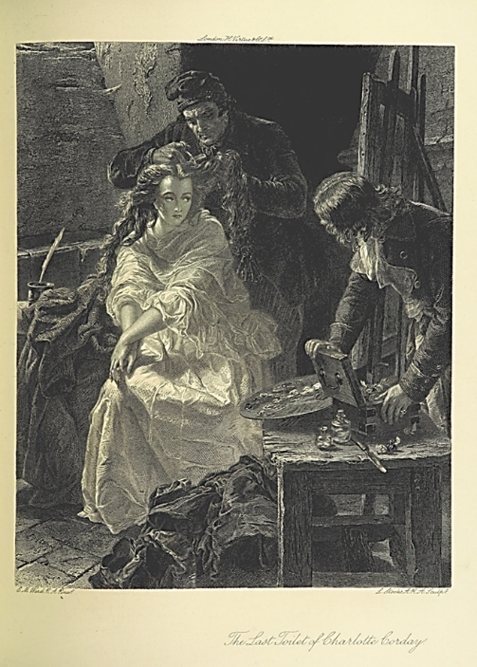
3 stages:
Description
Analysis
Critical analysis

An exercise with an image

Stage 1:  Description | Stage 2:  Analysis | Stage 3:  Critical
Descriptive writing: example (c.100 words)
In this black and white engraving, a woman is sitting in a dark room, clad in an elegant white dress, with hands interlaced on her knee. A man in a conical cap is cutting her hair while she’s looking longingly at a painting on the easel to her left. Her eyes look alert. An artist is watching her as he is packing up his paints on the table. Other objects in the room include a palette knife in the right hand corner and a quill pen on the left, as well as a heap of dark fabric at the foot of the woman.
Analytical writing: example (c.200 words)
The central focus of this black and white engraving is Charlotte Corday sitting in her prison cell, a seemingly unlikely place for a beautiful woman like that. She is clad in an elegant white dress, which stands out in the darkness of the surroundings creating a jarring and intriguing portrait that evokes threatened innocence and virtue. Her hands are clasped on her knee, implying modesty and anxiety. A man in a conical cap, popular in mid-nineteenth century, is cutting her hair – symbol of her femininity – while she’s looking longingly at a painting on the easel to her left. The shearing is a humiliating ritual and her eyes look alert, creating an impression of determination in the face of indignity. An artist is watching her, perhaps looking for approval of his portrait, as he is packing up his paints on the table. Other objects in the cell include a palette knife in the right hand corner, which hints at a possible crime Corday committed, and a quill pen on the left that symbolises the power of written word, as well as a heap of dark fabric at the foot of the woman. The mood is sombre and anticipating as she will soon be walked off to her execution.
[Plain text = descriptive writing Bold text = analytical writing]
Critical writing: example (c.400 words)
The central focus of this black and white engraving is Charlotte Corday sitting in her prison cell, a seemingly unlikely place for a beautiful woman like that. It was created by E.M. Ward, English historical painter and illustrator (Bendiner, 2004), and published in London in 1869 (The British Museum), seven decades after the event it represents. As the famous assassin of the French revolutionary Jean-Paul Marat during the terror stage of the French Revolution, in 1793, Corday quickly became a subject of not only multiple paintings, engravings and cheap illustrations but also plays, novels, short stories and historical narratives (Kindleberger, 1994, p.971). In this representation, she is clad in an elegant white dress, which stands out in the darkness of the surroundings creating a jarring and intriguing portrait that evokes innocence and virginity, which her post mortem confirmed much to the chagrin of her critics (Gelbart, 2004, p.205). Her hands are clasped on her knee, implying modesty and anxiety. A man in a conical cap, also called a Phrygian cap or a liberty cap as it was a Roman symbol of freedom (Korshak, 1987), is cutting her hair – symbol of her femininity – while she is looking longingly at a painting on the easel to her left. Her ultra-feminine portrayal could be seen as a response to the contemporary negative representations of her as an unattractive, embittered and man-hating militant (Gullickson, 2014). The shearing is a humiliating ritual and her alert eyes create an impression of determination in the face of indignity. The artist whom she requested to paint her portrait, possibly Jean Jacque Haure (Gelbart, p.204), is watching her, perhaps looking for approval of his portrait, as he is packing up his paints on the table. Other objects in the cell include a palette knife in the right hand corner, which hints at the crime Corday committed when she plunged a kitchen knife into Marat’s heart killing him instantly, and a quill pen on the left that symbolises the power of written word, which is what Corday acknowledged by assassinating the journalist whom she saw as instigating hatred and representing the ‘tyranny of the mob’ (Yarrington and Everest, 2016, p. 7). The mood is sombre and anticipating as she will soon be walked off to her execution at the guillotine, the preferred method of decapitating the enemies of state during the Reign of Terror in Revolutionary France (Croker, 1853). Following her political act, Corday became a mythical figure, a symbol of the French revolution, to which visual representations such as this one significantly contribute (Hilger, 2010, p.71).
[Plain text = descriptive writing Bold text = analytical writing Underlined text = critical writing]
Developing ideas into paragraphs: example, c.700 words

Charlotte Corday has fascinated artists for over two centuries, becoming a subject of not only multiple paintings, engravings and cheap illustrations but also plays, novels, short stories and historical narratives (Kindleberger, 1994, p.971). These portrayals vary greatly in terms of the sympathies expressed by their creators – from artists presenting Corday as an unattractive madwoman to those hailing her as a revolutionary heroine. The black and white engraving produced by E.M. Ward, an English historical painter and illustrator, and published in London in 1869 (The British Museum), stands out as a unique portrayal of this assassin of the French revolutionary Jean-Paul Marat during the French Revolution. Through a skilful use of allegory and deep knowledge of the historical context, Ward created a portrait that is both visually appealing and conveys a political perspective that aimed to recover Corday’s legacy and inspire the artist’s contemporaries in Victorian Britain.
By including a range of heavily symbolic items in the painting, E.M. Ward offered a new and visionary interpretation of Charlotte Corday’s actions, over seven decades after her tragic death. The image’s central focus is Corday herself, sitting in her dark prison cell, a seemingly unlikely place for a beautiful woman like that. Other striking objects in her surroundings include a palette knife in the right hand corner, which hints at the crime Corday committed when she plunged a kitchen knife into Marat’s heart killing him instantly, and a quill pen on the left that symbolises the power of written word, which is what Corday acknowledged by assassinating the journalist whom she saw as instigating hatred and representing the ‘tyranny of the mob’ (Yarrington and Everest, 2016, p.7). Ward presents Corday’s face as beautiful and her pensive look makes her seem aware of her fate, calling for viewers’ sympathy.
Positioned at the centre of the painting, Charlotte Corday is the suggested heroine we are invited to admire. She is clad in an elegant white dress, which stands out in the darkness of the surroundings creating a jarring and intriguing portrait that evokes innocence and virtue. This use of white is a visual reminder that despite Corday’s critics’ attempts to smear her character and present her as a woman of loose morals, her post mortem confirmed that she was actually a virgin (Gelbart, 2004, p.205). While her contemporaries tried to denounce her brave actions by exploiting the perceived gender-based weaknesses of her persona, Ward’s portrait reinforces the positive elements that transcend the confines of eighteenth century’s society and politics.
Corday’s ultra-feminine portrayal in the painting could be seen as a response to the contemporary negative representations of her as an unattractive, embittered and man-hating militant (Gullickson, 2014). The positioning of her body, with hands clasped on her knee, strongly implies modesty and anxiety, while her long, wavy and slightly exaggerated mane represents vulnerable femininity. A man in a liberty cap – a Roman symbol of freedom (Korshak, 1987) that was popular in mid-nineteenth century – is just about to cut this hair, thus taking away her innocence and beauty. The shearing is a humiliating ritual and her averted eyes seem alert. The artist’s juxtaposition of Corday’s good looks and the shearer’s crude treatment of her creates an impression of determination in the face of indignity, resulting in the viewers’ empathy for the victim.
The mood of the painting is sombre and anticipating as Corday will soon be walked off to her execution at the guillotine, the preferred method of decapitating the enemies of state during the Reign of Terror in Revolutionary France (Croker, 1853). While being prepared through her ‘last toilet’, Corday is looking longingly at a painting on the easel to her left. The artist whom she requested to paint her portrait, possibly Jean Jacque Haure (Gelbart, 2004, p.204), is packing up his paints on the table and watching her, looking for her approval of the portrait. This is perhaps Ward’s indirect way of asking his own audience for an approval of his work, as he followed in the footsteps of many other artists who were fascinated with Corday. Following her political act, Corday became a mythical figure, a symbol of the French revolution, to which visual representations such as this one significantly contribute (Hilger, 2010, p.71). Ward’s engraving, with artistic choices that reveal his political stance on her act as gallant and heroic, adds a significant voice to the cultural legacy of Charlotte Corday.

Reference list:
Bendiner, K. (2004) ‘Ward, Edward Matthew (1816–1879)’. Oxford Dictionary of National Biography, Oxford University Press. Available at http://www.oxforddnb.com/view/article/28683 (Accessed 1 June 2016).
Croker, J. W. (1853) History of the Guillotine. London: J. Murray.
Gelbart, N. R (2004) ‘The Blonding of Charlotte Corday’. Eighteenth-century studies 38.1, pp. 201-221.
Gullickson, G. L. (2014) ‘Militant Women: representations of Charlotte Corday, Louise Michel and Emmeline Pankhurst’. Women's History Review 23.6, pp.837-852.
Hilger, S. (2010) ‘The Murderess on Stage: Christine Westphalen’s Charlotte Corday (1804)’. In: Bielby C. and Richards, A., eds. Women and Death 3: Women's Representations of Death in German Culture Since 1500. New York: Camden House.
Kindleberger, E R. (1994) ‘Charlotte Corday in text and image: A case study in the French Revolution and women's history’. French Historical Studies, pp.969-999.
Korshak, Y. (1987) ‘The Liberty cap as a revolutionary symbol in America and France’. Smithsonian Studies in American Art 1.2, pp.53-69.
Ward, E.M. (1869) The Last Toilet of Charlotte Corday [engraving]. London. British Museum Collection Online. Available at http://www.britishmuseum.org/research/collection_online/collection_object_details.aspx?objectId=3203249&partId=1&people=106348&peoA=106348-2-60&page=1 (Accessed 1 June 2016).
Yarrington, A. and Everest, K. eds. (1993) Reflections of Revolution: Images of Romanticism. London and New York: Routledge.

